Status of State Electric Industry Restructuring Activity
-- as of March 2002 --
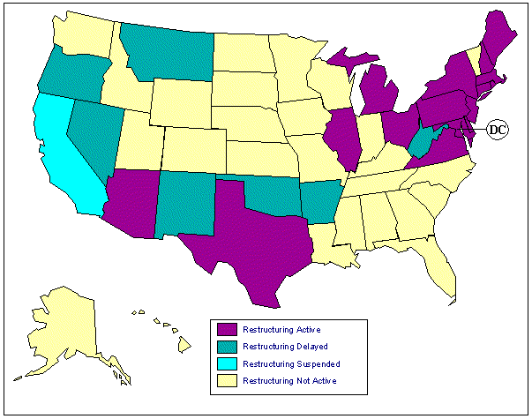
This site provides an overview of the status of electric industry restructuring in each state. Twenty-four states and the District of Columbia have either enacted enabling legislation or issued a regulatory order to implement retail access. The local distribution company continues to provide transmission and distribution (delivery of energy) services. Retail access allows customers to choose their own supplier of generation energy services, but each state's retail access schedule varies according to the legislative mandates or regulatory orders. The information in the “Status of State Electric Industry Restructuring Activity Map” was gathered from state public utility commissions, state legislatures, and utility company web pages.
The state activity map is coded by color to indicate each state's restructuring progress. Purple colored states are active in the restructuring process, and these states have either enacted enabling legislation or issued a regulatory order to implement retail access. Retail access is either currently available to all or some customers or will soon be available. Those states are Arizona, Connecticut, Delaware, District of Columbia, Illinois, Maine, Maryland, Massachusetts, Michigan, New Hampshire, New Jersey, New York, Ohio, Pennsylvania, Rhode Island, Texas, and Virginia. Yellow colored states are not actively pursuing restructuring. Those states are Alabama, Alaska, Colorado, Florida, Georgia, Hawaii, Idaho, Indiana, Iowa, Kansas, Kentucky, Louisiana, Minnesota, Mississippi, Missouri, Nebraska, North Carolina, North Dakota, South Carolina, South Dakota, Tennessee, Utah, Vermont, Washington, Wisconsin, and Wyoming. A green colored state signifies a delay in the restructuring process or the implementation of retail access. Those states are Arkansas, Montana, Nevada, New Mexico, Oklahoma, and Oregon. California is the only blue colored state because direct retail access has been suspended.
Each state has a link to several tables dedicated to summarizing regulatory orders, legislation, investigative studies, retail access, stranded costs, public benefits programs, pilot programs, and any additional information. The information is updated on a monthly basis, and gathered from a variety of sources including the state legislatures, public utility commissions, state energy commissions, Office of the Governor, and news agencies.
Source: Energy Information Administration.

CONTACT
Ms. Channele Carner
channele.carner@eia.doe.gov
Phone: (202) 287-1928
Specialized Services from NEIC
Home | Petroleum | Gasoline | Diesel | Propane | Natural Gas | Electricity | Coal | Nuclear
Renewables | Alternative Fuels | Prices | States | International | Country Analysis Briefs
Forecasts | Processes | Sectors
Page last modified on 05/09/2002 05:49:23

