
Home > Electricity > Electricity Restructuring Fact Sheets > Electricity Retail Price

Electricity Retail Price Fact Sheet
The restructuring of the electric power industry is transforming the historically monopolistic industry into one that will have increased competition in its generation and retail sales components, thereby changing the way electricity is priced, traded, and marketed in the United States.
- Over the past 40 years, U.S. retail electricity customers have seen two distinct trends in nominal electricity prices—prices unadjusted for the effects of inflation. High construction costs and increased fuel prices contributed to increasing retail electricity prices in the 1970s and 1980s. Improved operating efficiencies, reduced construction costs, and other factors have resulted in a leveling of nominal electricity prices in the 1990s (see graph).
- Trends in real electricity prices—prices from which the effects of inflation are eliminated—show somewhat different results. U.S. retail electricity prices declined through the 1960s, increased through the 1970s and mid-1980s, and have been decreasing steadily since. Currently, the Nation as a whole is enjoying the lowest real electricity prices since the late 1960s (see graph).
- Because of inherent efficiencies in large volume purchases, industrial customers generally realize lower electricity prices than residential and commercial customers. In 1999, industrial customers paid an average 4.43 cents per kilowatthour (kWh), while residential and commercial customers paid an average 8.16 cents per kWh and 7.26 cents per kWh, respectively.
- State level retail electricity prices vary considerably across the United States. Generally, States in New England have the highest average retail electricity prices, while States in the Northwest have the lowest. Variation in prices is caused by many factors including access to low cost fuels for generating power, State taxes, and the mix of power plants in the States (see map).
- Future trends in retail electricity prices are uncertain. They will depend on capacity, weather, fuel prices, electricity use, and electricity generation, transmission, and distribution costs.
- It is unclear what effect the introduction of competition at the retail level will have on future retail prices. For States that have already deregulated, a phased approach to creating competitive markets has typically been used. This, however, delays the full effects competition may have on retail prices.

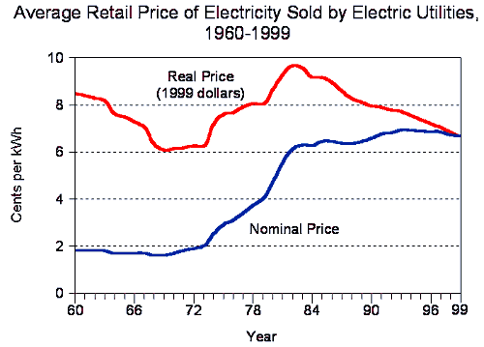D

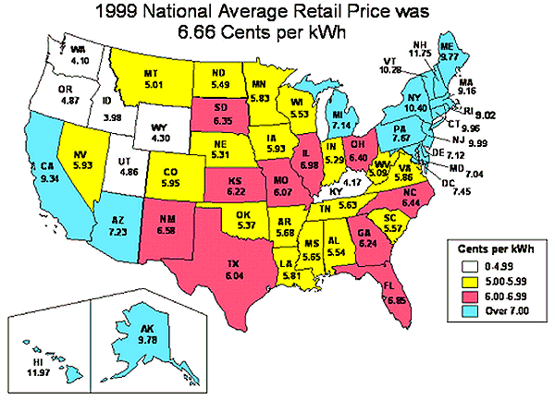D

Related Websites
- Energy Information Administration, Monthly Energy Review (Table 7.5):
http://www.eia.doe.gov/mer/elect.html
- Energy Information Administration, Annual Energy Review (Table 8.13):
http://www.eia.doe.gov/emeu/aer/elect.html
- Energy Information Administration, Electric Power Monthly (Tables 44-55):
http://www.eia.doe.gov/cneaf/electricity/epm/epm_sum.html
- Energy Information Administration, Wholesale Electric Power Links:
http://www.eia.doe.gov/cneaf/electricity/wholesale/wholesalelinks.html
- Energy Information Administration, Electricity Revenue, Sales and Price by State and Utility (Tables 14-17):
http://www.eia.doe.gov/cneaf/electricity/esr/esr_tabsh.html
- Energy Information Administration, Electricity Revenue, Sales and Price for Power Marketers (Table C4):
http://www.eia.doe.gov/cneaf/electricity/esr/esr_tabsh.html
- Energy Information Administration, U.S. Average Monthly Bills by Sector, Census Division, and State (Table 1): http://www.eia.doe.gov/cneaf/electricity/esr/esr_tabsh.html
- Federal Energy Regulatory Commission, Bulk Power Markets:
http://www.ferc.fed.us/electric/bulkpower.htm

Need Help?
phone: 202-586-8800
email: infoctr@eia.doe.gov
Specialized Services from NEIC
Energy Information Administration, EI 30
1000 Independence Avenue, SW
Washington, DC 20585

URL: http://www.eia.doe.gov/cneaf/electricity/page/fact_sheets/retailprice.html

Page last modified on 05/20/2002 10:12:09

