Electricity Supply and Demand Fact Sheet
The U.S. electric power industry is in transition as it moves toward a competitive environment in the wholesale and retail markets. Competitive markets are expected to encourage investments in new electric generating capacity to meet growing customer needs. These evolving markets are also expected to ensure that sufficient future capacity will exceed the projected peak demand. The extra capacity is needed to act as a buffer against unexpected increases in customer demands and losses of generating supply due to events like equipment outages, which might cause electricity blackouts.
- The electric power industry has not determined what percentage level is adequate for the electric generating capacity margins to guarantee electricity at all times and under varying conditions. The capacity margins can be affected by the availability of electricity supply (equipment failure) and by unanticipated electricity usage by customers. Extreme weather conditions can cause both of these to happen at once, without substantial warning. The effects of these potential supply shortages can be mitigated with larger capacity margins, but it is difficult to determine the level of capacity margins capable of providing adequacy at all times and under varying conditions.
- Under the traditional regulated regime, capacity margin calculations were considered as part of long-term planning to ensure that enough capacity was available under typical adverse events. In the aftermath of deregulation, investor-owned utilities have divested their generating assets. They are no longer responsible for capacity planning as in the past. Capacity additions, therefore, may or may not keep pace with the growth in demand.
- Between 1978 and 1992, America's utilities' capacity margins averaged between 25 and 30 percent. Since 1992, the capacity margins have declined to less than 15 percent nationwide. However, in 2001, the decline is expected to reverse, as capacity margins reach 15.6 percent nationwide, with planned capacity expected to grow by 27.1 gigawatts and demand by 15.8 gigawatts.
- While the Nation overall has a 15.6 percent capacity margin for 2001, the 3 independent power grids that comprise the electrical systems in the lower-48 States differ in their level of capacity margins. The largest power grid (Eastern) dominates with nearly 75 percent of total U.S. electricity demand. However, with a capacity margin of 13.9 percent, the Eastern Power Grid has the lowest planned extra supply available this summer to meet expected demand (see table).
- The national capacity margin is expected to reach 18.4 percent in 2004 with electric generating capacity expected to reach 870.0 gigawatts, while electricity demand is projected to reach 709.6 gigawatts (see graph).
U.S. Capacity Margins, 2001
 | Eastern Grid | Texas Grid | Western Grid | U.S. Total
Demand  (Megawatts) | 501,405 | 53,414 | 114,830 | 669,649
Supply  (Megawatts) | 582,223 | 69,769 | 141,068 | 793,060
Capacity Margins  (Percent) | 13.9 | 23.4 | 18.6 | 15.6

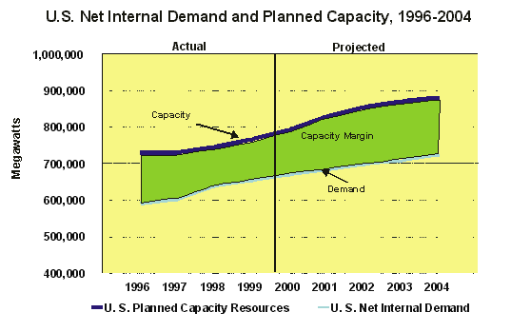

Related Websites
- Energy Information Administration Electric Power Annual Vol. 2, Table 40: http://www.eia.doe.gov/cneaf/electricity/epav2/epav2_sum.html
- North American Electric Reliability Council Summer and Winter Assessments: http://www.nerc.com/publications/annual.html
- North American Electric Reliability Council 10-Year Assessment: http://www.nerc.com/~filez/rasreports.html
- Edison Electric Institute: http://www.eei.org/products/stats/index.shtml

